**Course Performance Measurement System**

INFO 5100 Assignment 3

Team members:

Peichen Han

Yiqing Wang

Leqi Wei

***Objectives and Requirements***

1.1 Create a performance measurement solution to enable universities to measure the quality of the education they deliver to their students.

1.2 Track the jobs and promotions graduates get over time and assign rankings accordingly.

1.3 Track the connection of courses and their relevance to graduates' growth.

1.4 Enables college and university administrators to compare the performance of their academic units.

1.5 Define the ranking system for students to decide where they want to go for their studies.

***Demand Analysis***

**2.1 System Demand**

The establishment of a complete education quality performance evaluation system requires a stable and credible information input source, a visualized result display interface, and public performance evaluation standards.

1. The performance appraisal in the system comes from the evaluation reports submitted by the graduated students in different periods within five years, as well as the student's results during the school period, the student's comprehensive results during the school period, and other data-based measurement indicators. The evaluation reports submitted includes the development performance after graduation, the development of school education, and others.
2. The results of the education quality performance system are displayed on the web page or the interface of the school application program. Users can view the comprehensive scores of the education quality of the entire school, the scores of the education quality of each department, and the specific evaluation scoring indicators after clicking into the sub-page, and its other relevant information in the total score.
3. This system should be internal to the school, and only authorized users can perform corresponding operations, such as submitting results forms, viewing internal performance and so on. When the school’s ungraduated students and professors, faculties log in to the system, they can only view the course evaluation information, and cannot refuse to modify them. The data changes are completely depends on the evaluation report uploaded by graduated students, and their previous school performance. But the administrator has the authority to manually modify any data.

**2.2 Module function**

The quality of education assessment system mainly needs to meet three part of requirements: graduated student user, nominal user, and administrator user.

The first is the requirement of graduated students, which have the permission to check the system, and evaluate education quality. The second is the requirement of users who can only view reviews. Don’t have the permission to evaluate education quality. This part including school faculties and staffs, and students who have not graduated. The last is the requirement of administrator users. They are the users who create and maintain this system, have the right to modify the system.

This system strictly divides the identities and permissions of administrators, teacher users, graduated student users and non-graduated student users. The administrator has the highest authority to add and view all information. Teachers and non-graduated students can only view, and only graduated students can upload evaluation reports. For all operations of this system, you must log in before proceeding. Through strict division of authority, better management can be carried out and user information security can be better protected.

1. The main requirements function of graduated students are: fill in the education quality evaluation form; check their own teaching quality evaluation; and check the overall education quality scores of the whole school.
2. The main requirements function of nominal users are: view the comprehensive scoring situation of the education quality of the whole school; and view the specific education quality evaluation form.
3. The main requirements function of the administrator user are: manage graduated and ungraduated student information, teacher information and education quality information.

***System Establishment***

**3.1 Class Diagram**

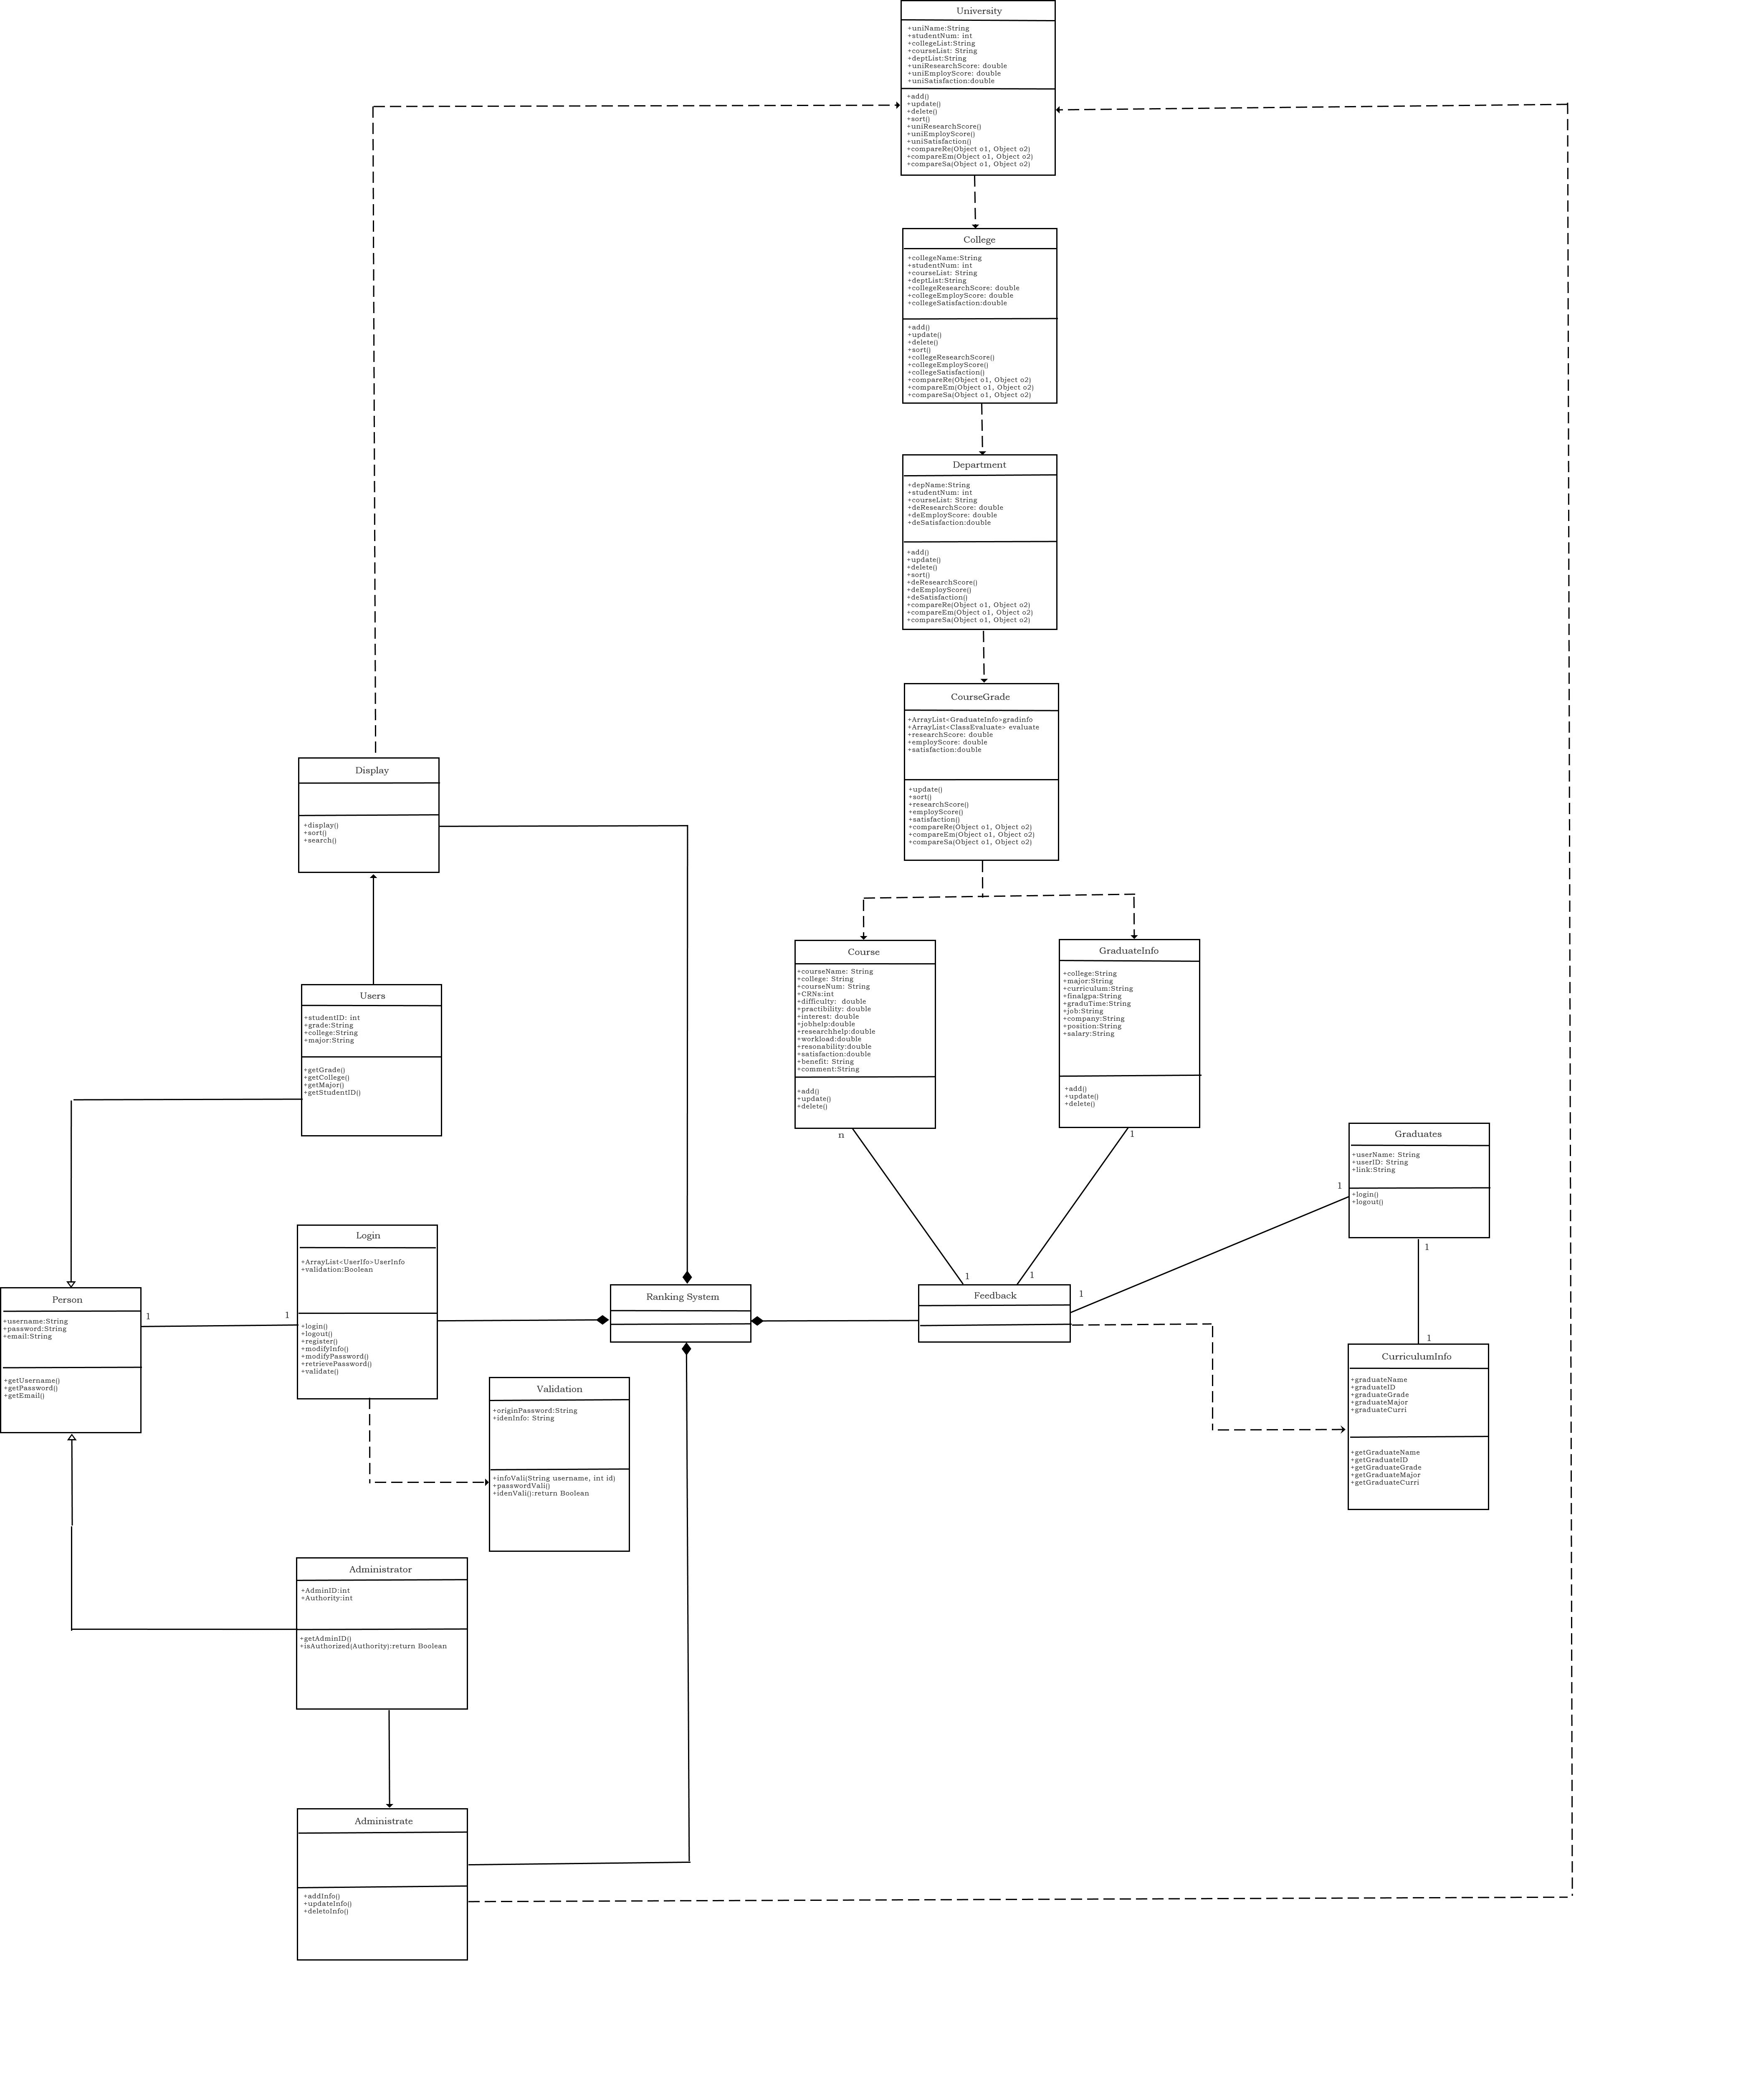

1. Graduates’ Feedback

According to the information during the study period of graduates, the system will generate the information table of course selection of graduates and send it to graduates in the form of invitation link. Graduates fill in their personal work profile and course evaluation information online.

1. Course Evaluation

According to graduates' job situation, future learning situation and course satisfaction, courses are scored from three dimensions, *Research Score*, *Employment Score* and *Satisfaction*. The score reflects the performance of the course in the direction of research and employment promotion and the relationship to the future development of students, whether it is biased towards research or employment.

1. Display

Courses are graded and ranked from three dimensions: research score, employment score and satisfaction, according to graduates' work situation, future learning situation and course satisfaction. Four categories of course, department, college and school are defined as academic units, ranging from small to large, so as to realize the teaching level comparison among courses, departments and colleges n. School teaching evaluation data is stored in the background and displayed in the front page.

1. User Log In

User login is divided into common user login and administrative user login. Set identity validation on the login screen. After logging in, ordinary users can centrally view and search the list of course evaluation information, which is conducive to students' personal learning planning through understanding each course.

1. Administration

Administrators can add, modify, update and delete School teaching evaluation data after logging in. The manager maintains the background data reasonably and effectively.

**3.2 Sequence Diagrams**

A) Graduates’ Feedback

a) Feedback

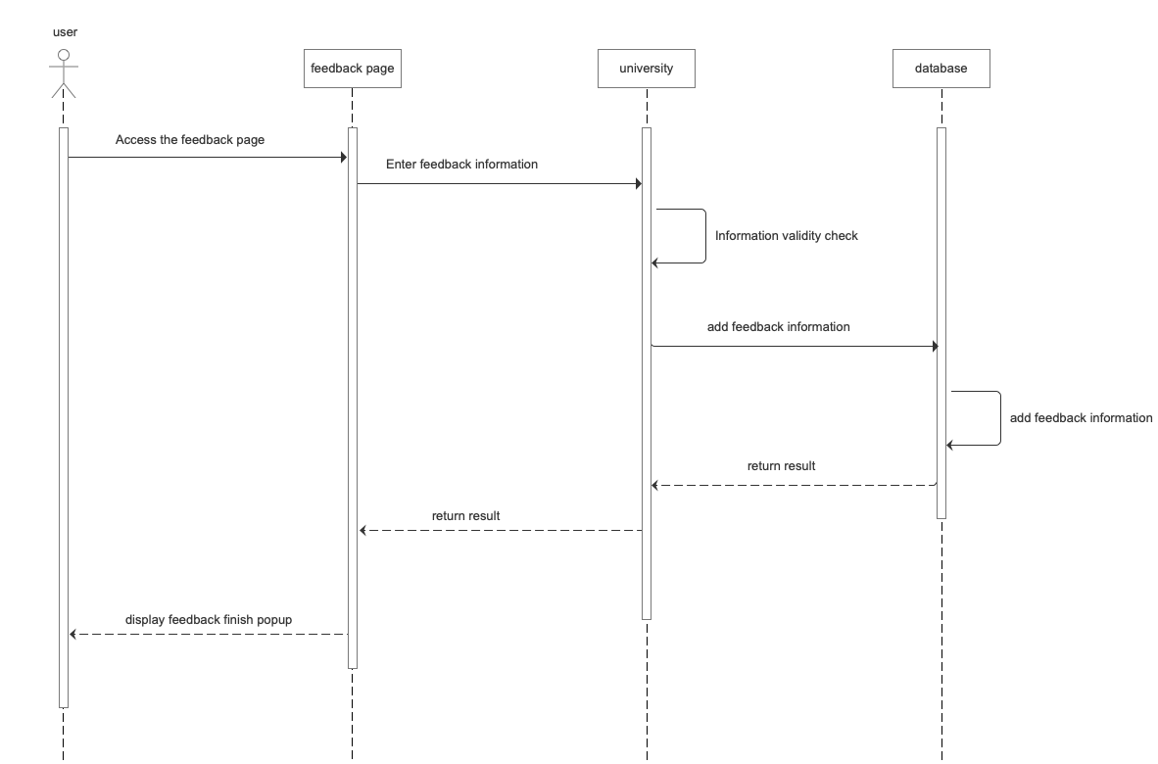

b) Feedback_false

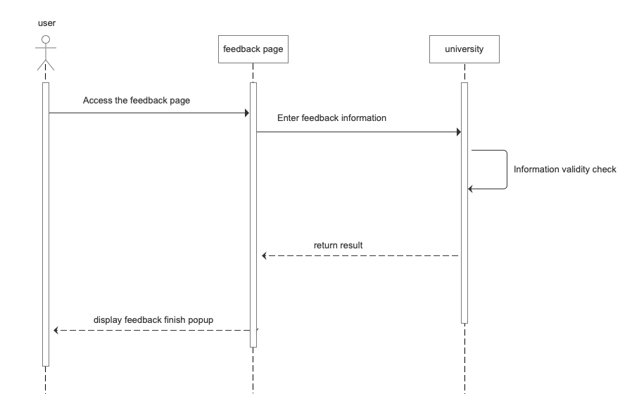

B) Log in

a) Sign Up

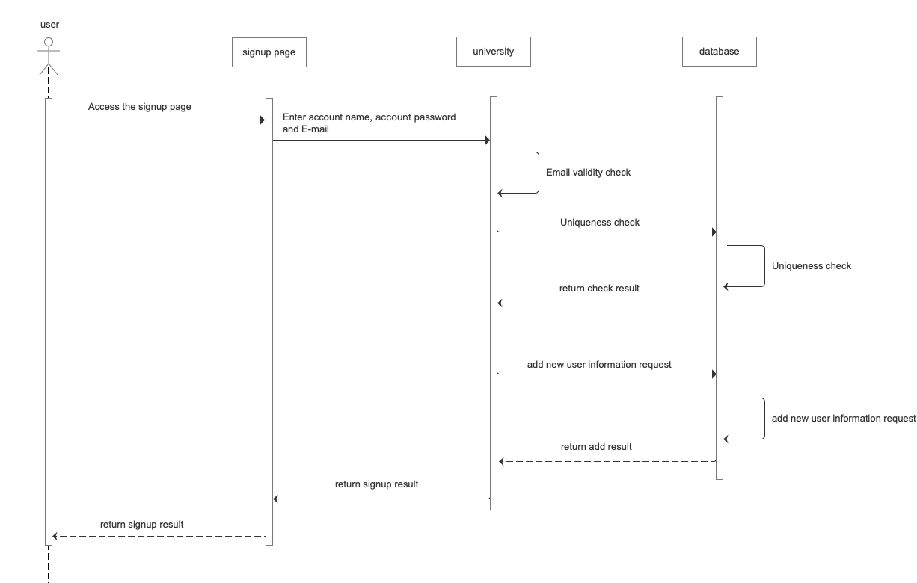

b) Signup_false

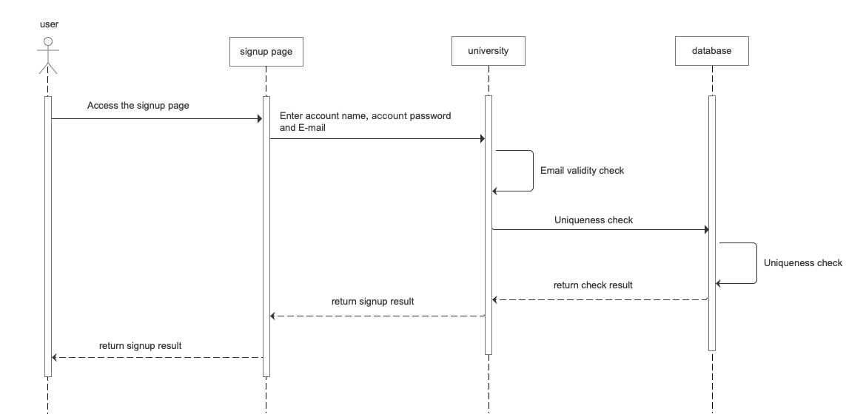

c) Log In

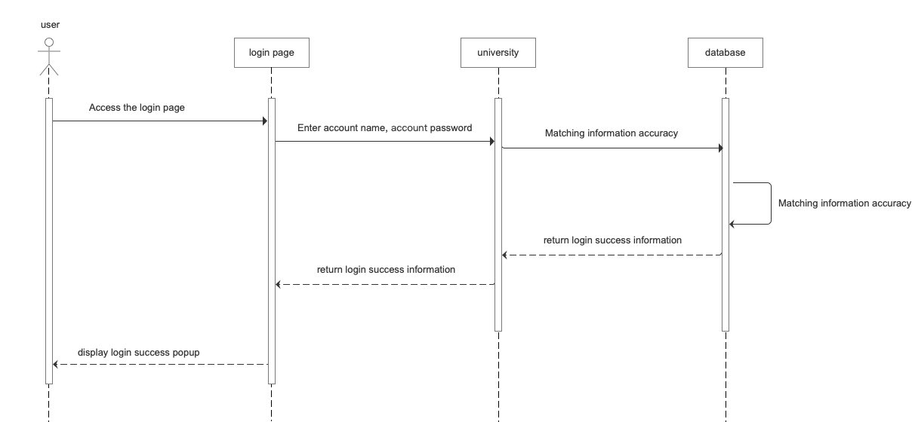

1. Login_false

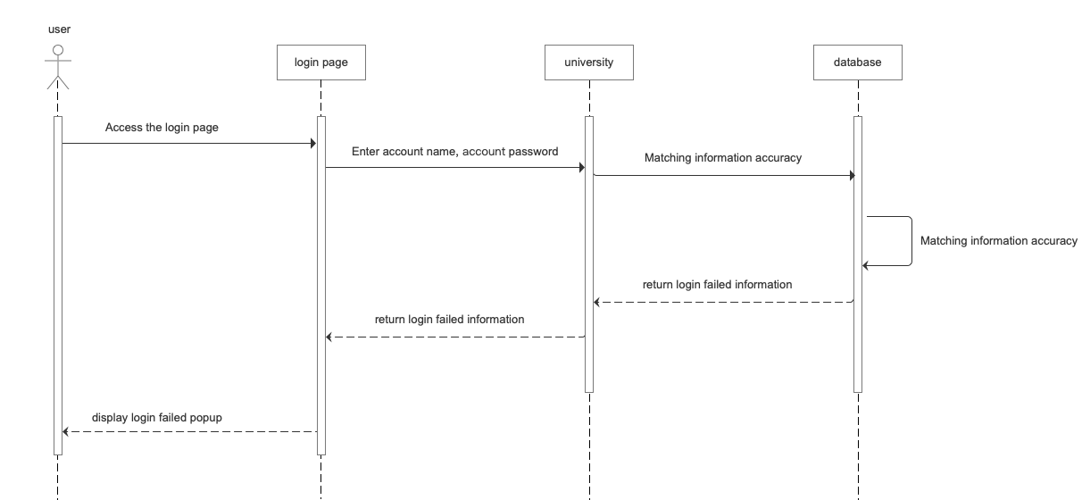

C) User Search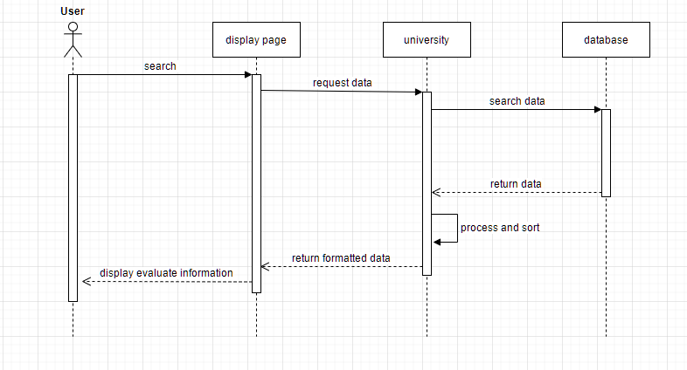

D) Administrator

a) Administrator Add

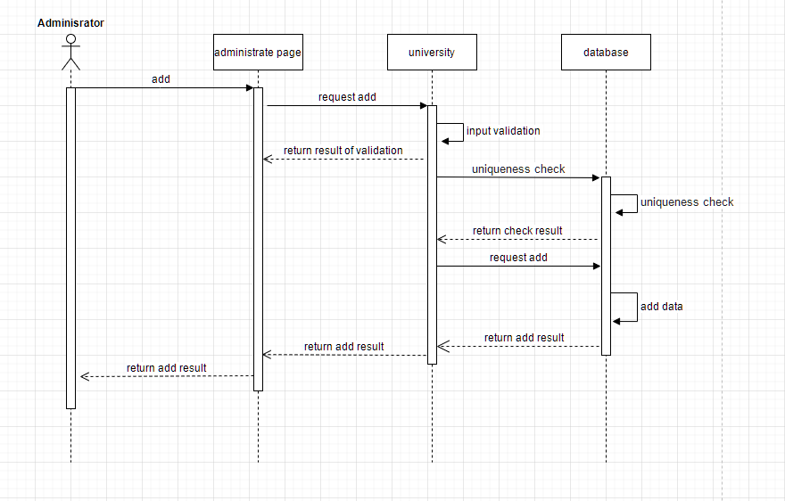

b) Administrator Add(uniqueness check false)

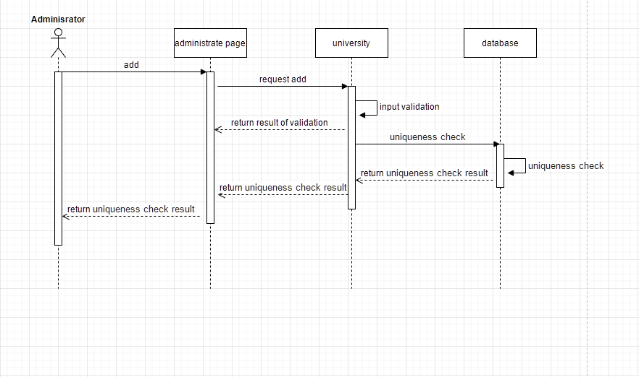

c) Administrator Add(input invalid)

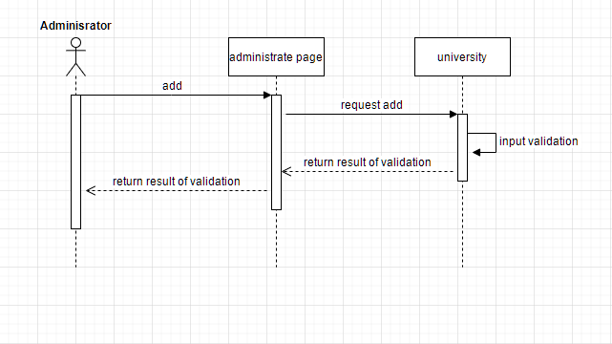

d) Administrator Update

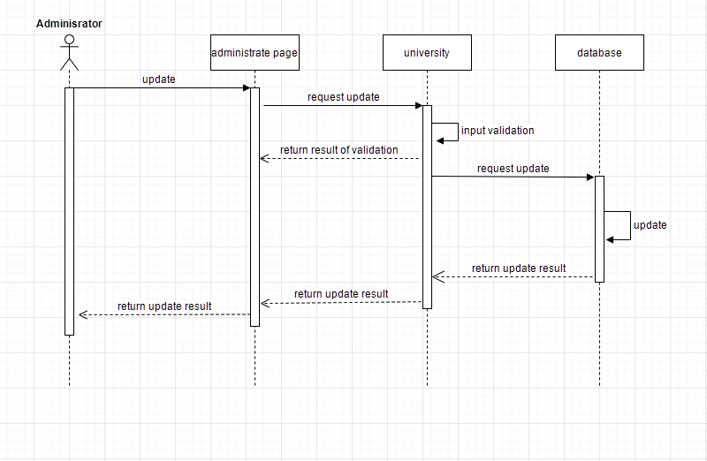

e) Administrator Update(input invalid)

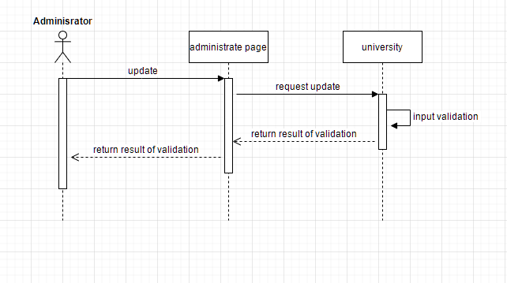

f) Administrator Delete

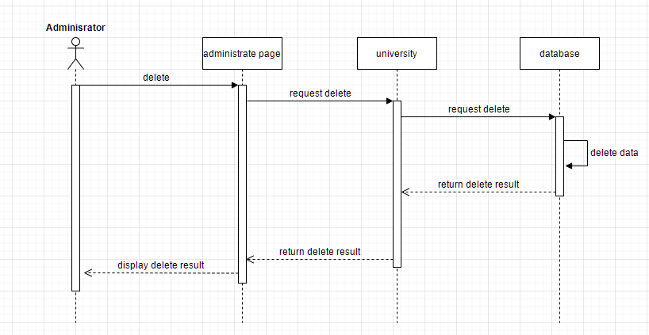

***Dashboard Design***

4.1 Dashboard screenshots

A) Graduates’ Feedback

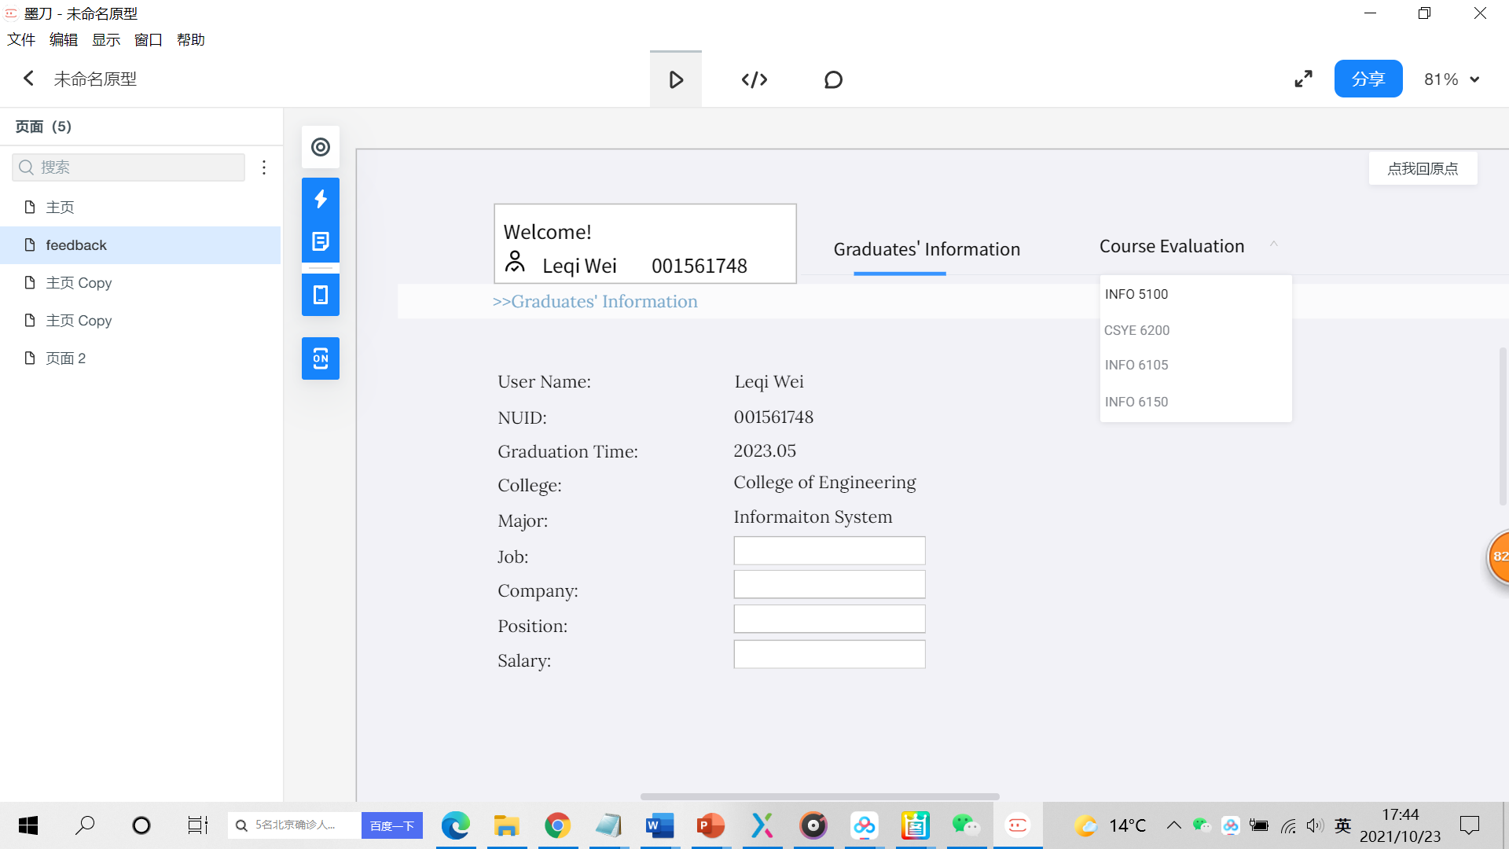

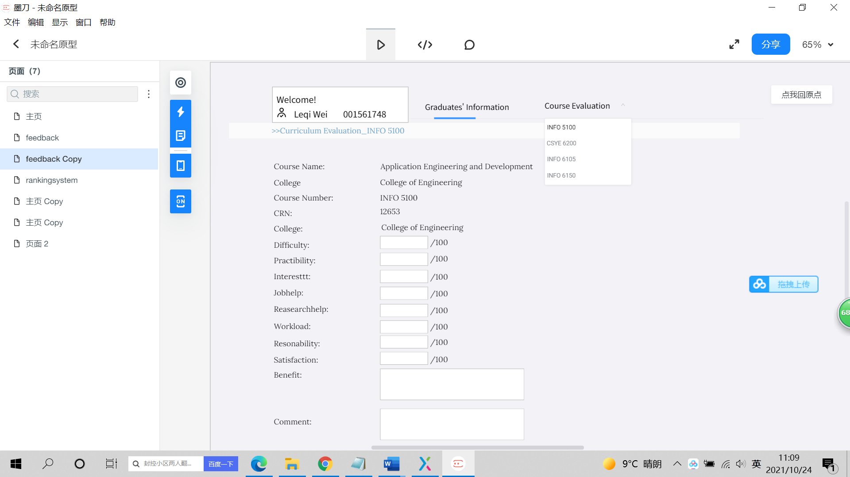

B）User Login

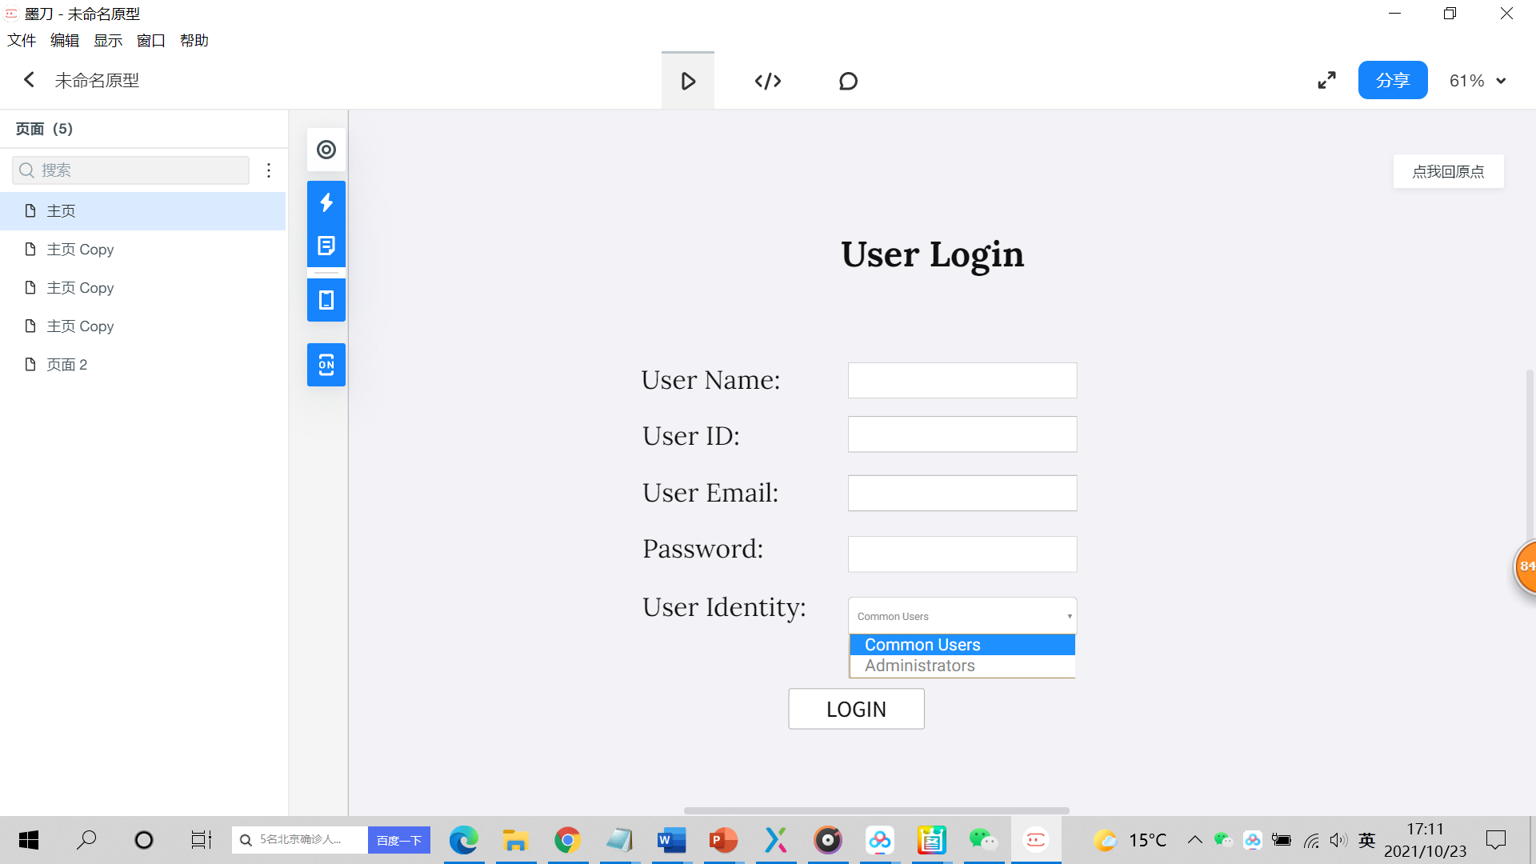

C）Display

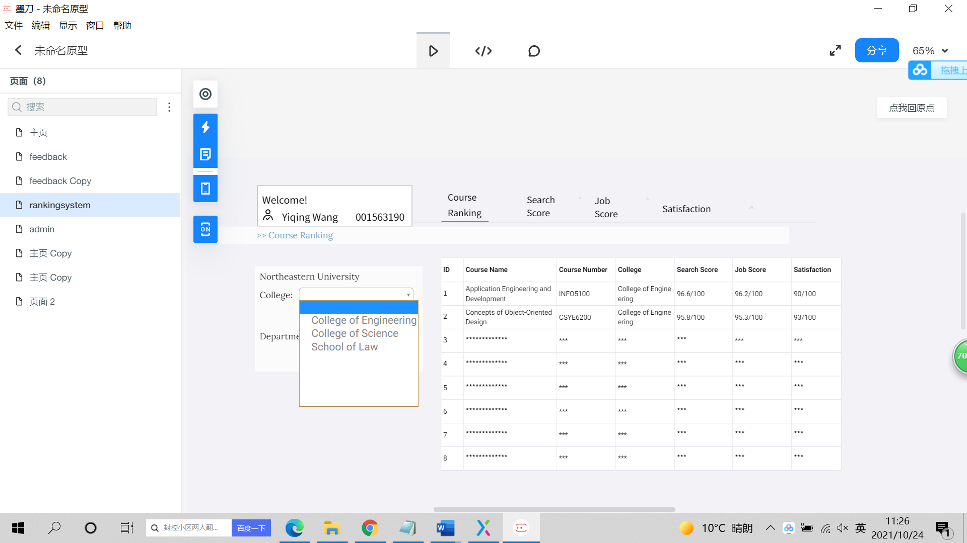

D）Administration

